**VISVESVARAYA TECHNOLOGICAL UNIVERSITY, BELAGAVI**



**A MINI PROJECT REPORT ON**

**“GYM MANAGEMENT SYSTEM”**

***A Mini Project Report Submitted in Partial Fulfilment of Requirement for the 7th Semester B.E Course during the academic year 2019-2020***

**Submitted by**

**ABHISHEK S (3GN16CS002)**

**Under the guidance of:**

**Prof. AMIT KUMAR**

**.**

**DEPARTMENT OF COMPUTER SCIENCE AND ENGINEERING**

**GURU NANAK DEV ENGINEERING COLLEGE**

**BIDAR-585403, KARNATAKA**

**VISVESVARAYA TECHNOLOGICAL UNIVERSITY, BELAGAVI**

**GURU NANAK DEV ENGINEERING COLLEGE**

**BIDAR-585403, KARNATAKA**



**DEPARTMENT OF COMPUTER SCIENCE AND ENGINEERING**

**CERTIFICATE**

This is to certify that the mini project work entitled “**GYM MANAGEMENT SYSTEM**” is a bonafied work carried out by **ABHISHEK S (3GN16CS002)** in partial fulfilment of the requirements for the Bachelor’s degree in COMPUTER SCIENCE AND ENGINEERING of VISVESVARAYA TECHNOLOGICAL UNIVERSITY, BELAGAVI during the year 2019-2020. It is certified that this Mini Project Report has been approved as it satisfies the academic requirements.

__________________________ ______________________________ _______________________

**SIGNATURE OF GUIDE SIGNATURE OF EXTERNAL SIGNATURE OF HOD**

**ACKNOWLEDGEMENT**

### I am highly intended my project guide Prof. Amit Kumar, for guiding and giving me timely advices and suggestions in successful completion of project work “GYM MANAGEMENT SYSTEM”. My sincere thanks to Prof. Dhananjay Maktedar HOD of Computer Science and Engineering department for his whole hearted support in completion of project.

### I would like to express my deep sense of gratitude to principal Dr.Ravindra Eklarker GURU NANAK DEV ENGINEERING COLLEGE, BIDAR for his motivation and for creating the inspiring atmosphere in the college providing state of art facilities for preparation and delivery of project. Finally, I thank all the staff members who directly or indirectly helped me to complete this project.

ABHISHEK S (3GN16CS002)

|  |  |
| --- | --- |
| **CONTENTS** | |
|  | |
| CHAPTER 1 | INTRODUCTION |
| CHAPTER 2 | PROJECT FEATURES & OBJECTIVES |
| CHAPTER 3 | DESIGN & CONNECTIVITY |
| CHAPTER 4 | OUTPUT SNAPSHOTS |
| CHAPTER 5 | SYSTEM REQUIREMENTS |
| CHAPTER 6 | PLAGIARISM CHECK |
| CHAPTER 7 | COST ESTIMATION OF PROJECT |
| CHAPTER 6 | CONCLUSION |

**CHAPTER - 1**

**INTRODUCTION**

The two main sections:

Backend: codes that are written in python, PHP, ASP .net to name but a few by the developer

Frontend: which is markup showed by clients or users browsers, and for doing this we should use HTML (Hyper Text Markup Language), it just shows some elements for users and doesn't run any functions. When you go to a specific URL, your request is sent to your desired server and it'll render for your HTML of the site, in fact, the server runs any server-side functions.

The Front-End used in this project is HTML along with the CSS language.

* HTML stands for Hyper Text Markup Language
* HTML is the standard markup language for creating Web pages.
* HTML describes the structure of Web pages using markup
* HTML elements are the building blocks of HTML pages
* HTML elements are represented by tags
* HTML tags label pieces of content such as "heading", "paragraph", "table", and so on
* Browsers do not display the HTML tags, but use them to render the content of the page

**1.1 Advantages of HTML:**

1. The first advantage it is widely used.
2. Every browser supports HTML language.
3. Easy to learn and use.
4. It is by default in every window so you don't need to purchase extra software.
5. You can integrate HTML with CSS, JavaScript, PHP etc.

The back-end database used in this project is MySQL

It is a language used to interrogate and process data in a relational database. Originally developed by IBM for its mainframes, SQL commands can be used to interactively work with a database or can be embedded within a script or programming language as an interface to a database. Programming extensions to SQL have turned it into a full-blown database programming language, and all major database management systems (DBMSs) support it. ANSI standardized SQL.

But most DBMSs have some proprietary enhancement, which if used, makes SQL non-standard. Moving an application from one SQL database to another sometimes requires tweaking, the age-old problem in this business!

**1.2 Advantages of MySQL:**

1. SQL Queries can be used to retrieve large amounts of records from a database quickly.

2. SQL is used to view the data without storing the data into the object

3. SQL joins two or more tables and show it as one object to user

4. SQL databases use long-established standard, which is being adopted by ANSI &amp; ISO. Non-SQL databases do not adhere to any clear standard.

5. Using standard SQL, it is easier to manage database systems without having to write substantial amount of code

**CHAPTER – 2**

**PROJECT FEATURES & OBJECTIVES**

**2.1 About the Project:**

**Gym Management System** developed using PHP is an excellent solution for gyms with a large/growing number of members, or ones serving elite clientele. This solution helps to identify the user and manage their timely memberships.

In its working, each member is issued a membership card which is valid for a fixed number of gym sessions, or for a particular period of time, or a combination of the two, totally based on the payment policy. Once the time-frame or number of sessions expire, the machine notifies the member about the payment of renewal.

Hence, the system reduces hassle and any chances of quarrels between the members and the gym management. It can also generate multiple reports like monthly, weekly, daily, session wise.

**2.1.2 Main features are:**

1. Gyms Management
2. Gym Members Management
3. Payment Management
4. Trainers Management

**2.1.3 Objectives:**

1. Add different gyms.
2. Add payment areas.
3. Add members to gym.
4. Add different trainers of gym.
5. View different gyms.
6. View payment areas.
7. View members to gym.
8. View different trainers of gym.
9. Update and delete different values of gyms, payments made, gym member’s details and trainer’s information.

**CHAPTER - 3**

**DESIGN & CONNECTIVITY**

**3.1 BACK-END DESIGN**

**3.1.1 Conceptual Database Design (ER-Diagram)**

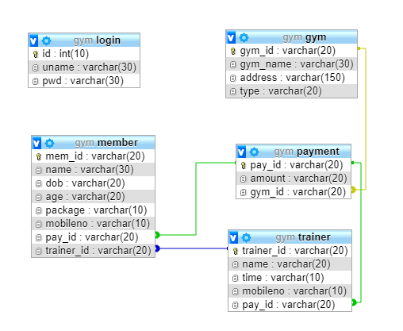

**3.2 FRONT-END DESIGN**

**3.2.1 Front-end web development details**

* **HTML** provides the basic structure of sites, which is enhanced and modified by other technologies like CSS and JavaScript.
* **CSS** is used to control presentation, formatting, and layout.
* **JavaScript** is used to control the behaviour of different elements.

**HTML**

HTML is at the core of every web page, regardless the complexity of a site or number of technologies involved. It's an essential skill for any web professional. It's the starting point for anyone learning how to create content for the web. And, luckily for us, it's surprisingly easy to learn.

**CSS**

CSS stands for Cascading Style Sheets. This programming language dictates how the HTML elements of a website should actually appear on the frontend of the page.

**JavaScript**

JavaScript is a more complicated language than HTML or CSS, and it wasn't released in beta form until 1995. Nowadays, JavaScript is supported by all modern web browsers and is used on almost every site on the web for more powerful and complex functionality.

**3.2.2 Connectivity (front end and Back end):**

**PHP is an amazing and popular language!**

It is powerful enough to be at the core of the biggest blogging system on the web (Word Press)! It is deep enough to run the largest social network (Facebook)! It is also easy enough to be a beginner's first server side language!

* PHP is an acronym for "PHP: Hypertext Pre-processor"
* PHP is a widely-used, open source scripting language
* PHP scripts are executed on the server
* PHP is free to download and use
* PHP files can contain text, HTML, CSS, JavaScript, and PHP code
* PHP code are executed on the server, and the result is returned to the browser as plain HTML
* With PHP you are not limited to output HTML. You can output images, PDF files, and even flash movies. You can also output any text, such as XHTML and XML.

**CHAPTER - 4**

**OUTPUT SNAPSHOTS**

**4.1.1 ADMIN PAGE**

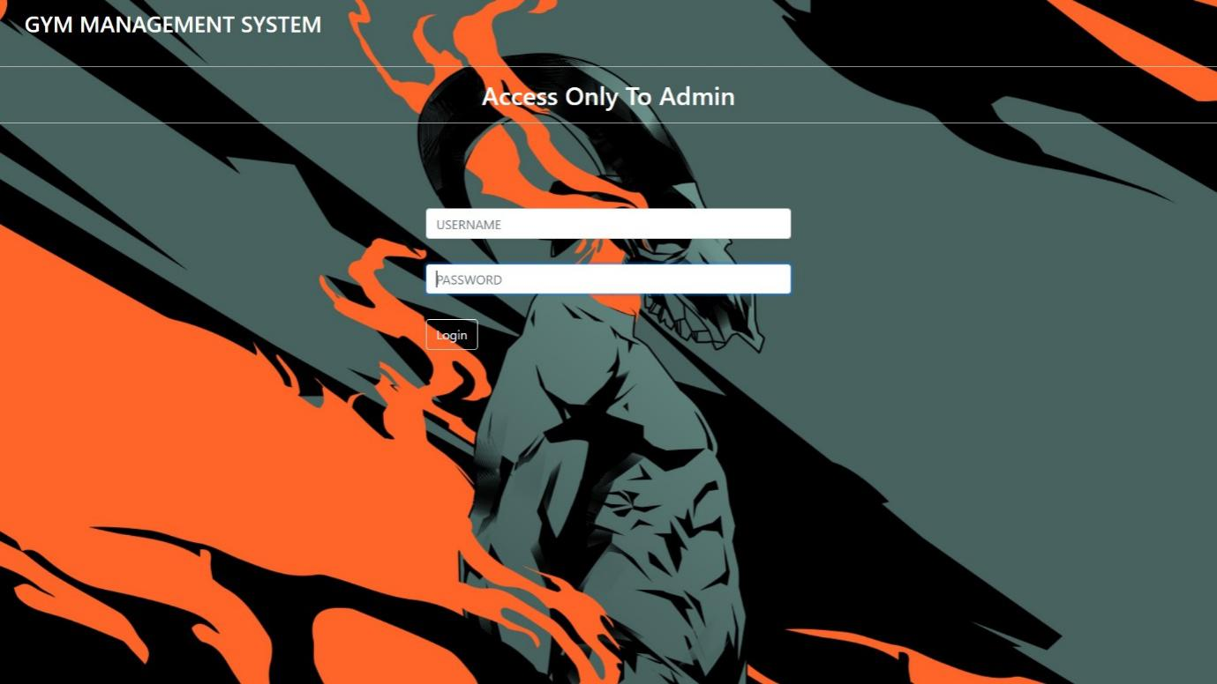

**4.1.2 ADD GYM**

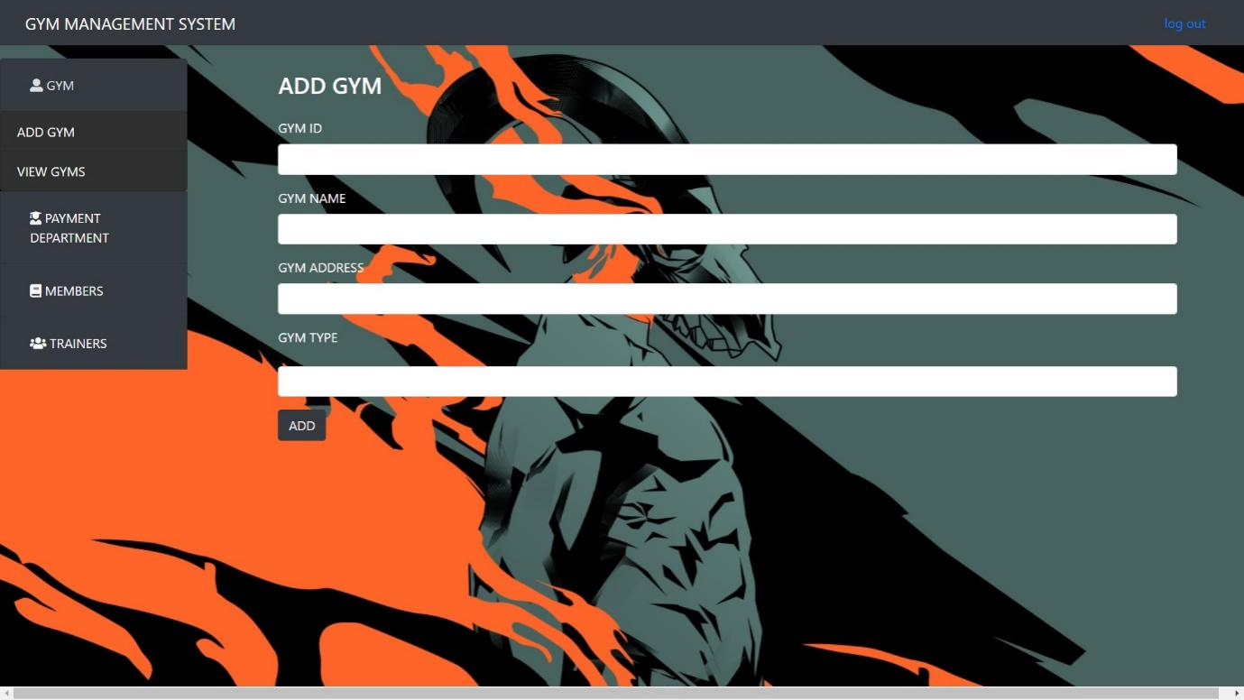

**4.1.3 MANAGE GYM**

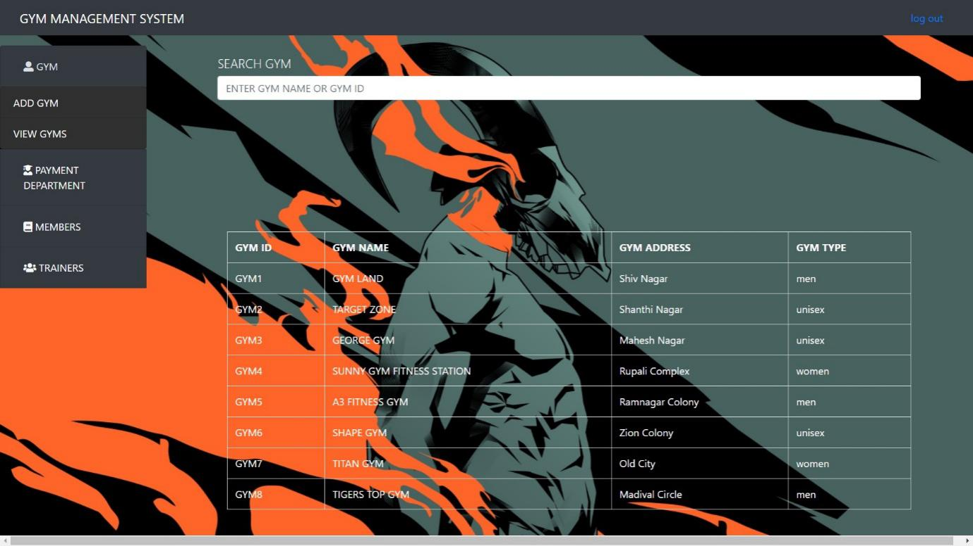

**4.1.4 ADD PAYMENT AREA**

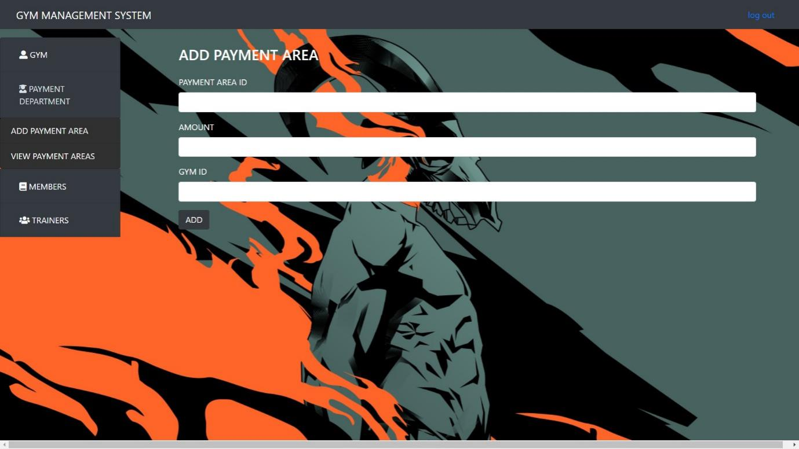

**4.1.5 MANAGE PAYMENT AREA**

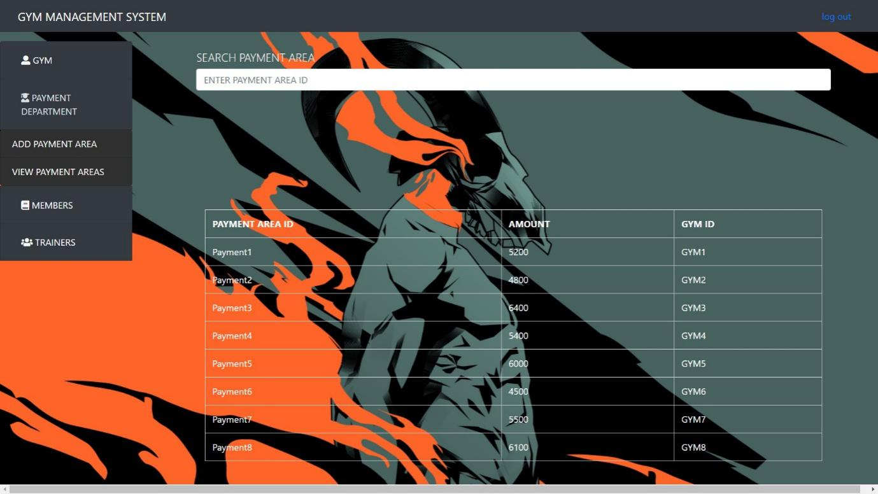

**4.1.6 ADD MEMBER**

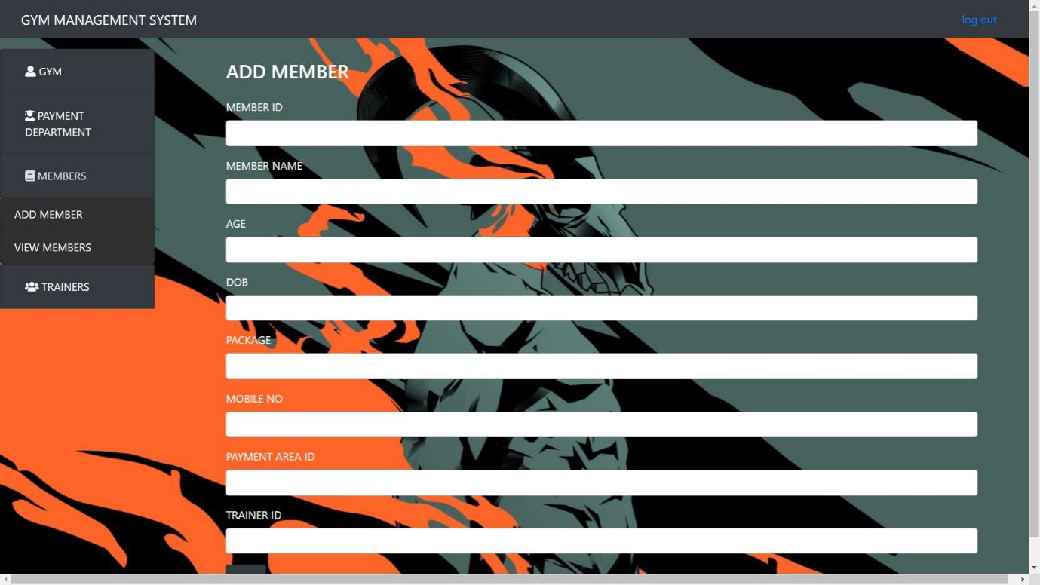

**4.1.7 MANAGE MEMBER**

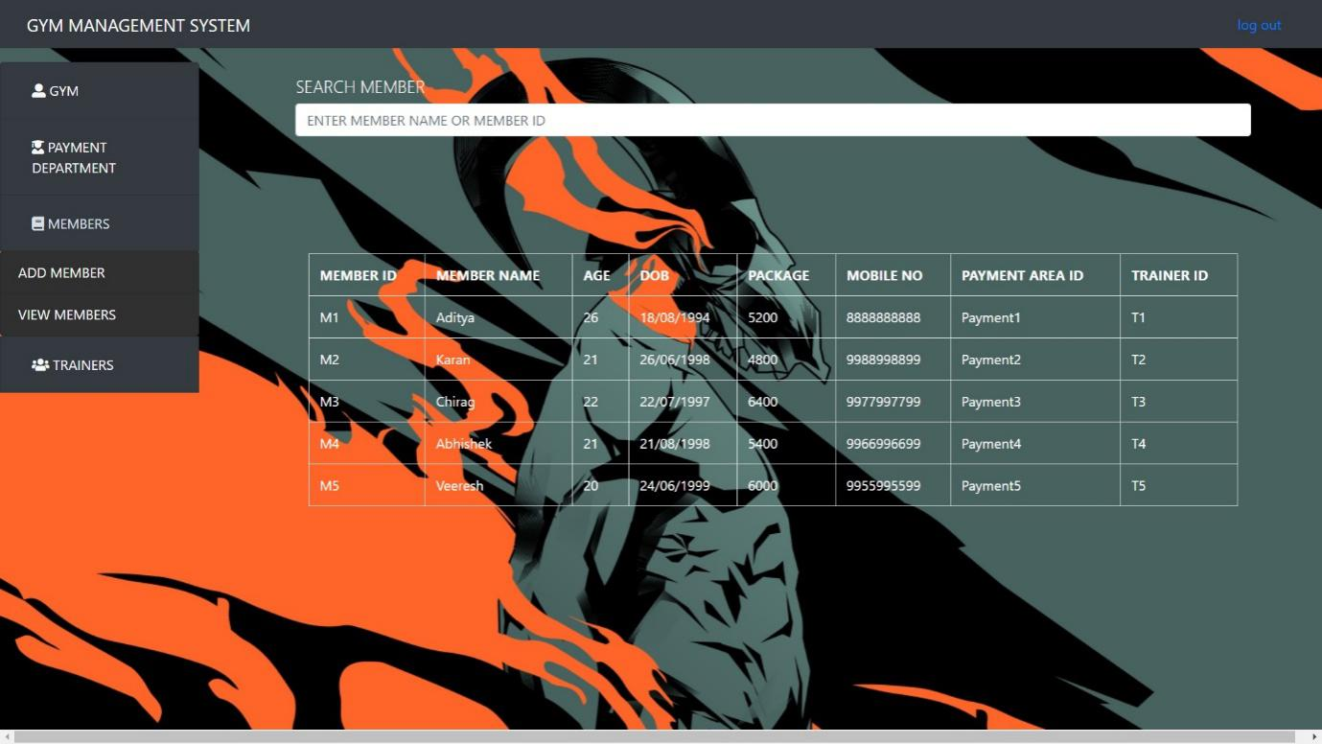

**4.1.8 ADD TRAINER**

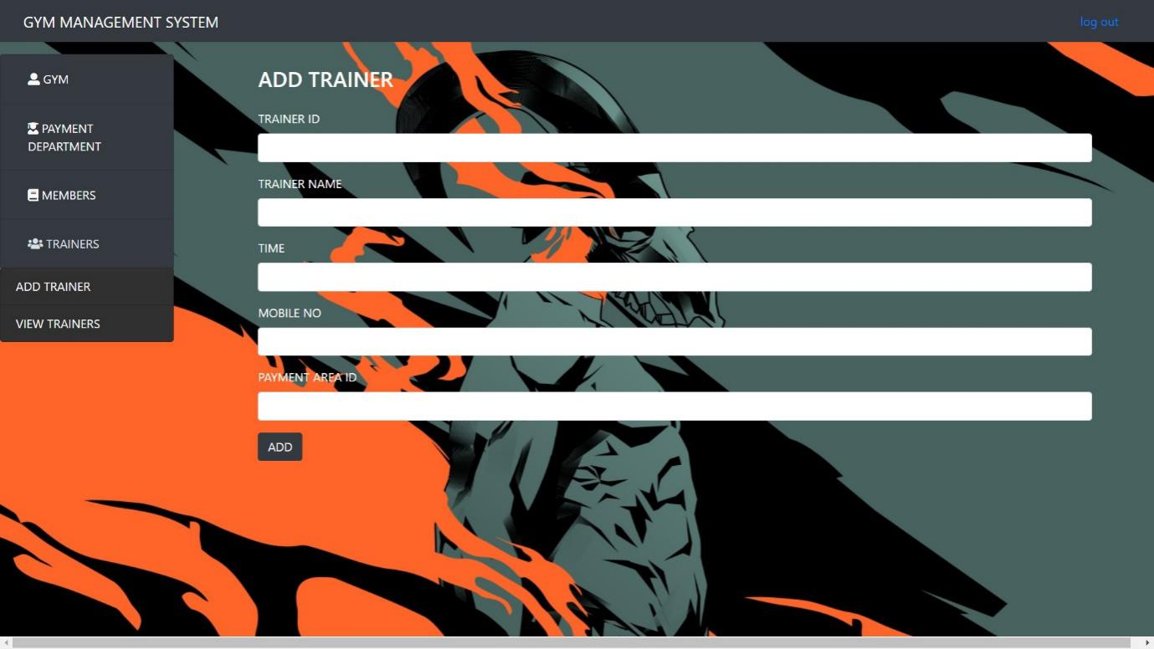

**4.1.9 MANAGE TRAINER**

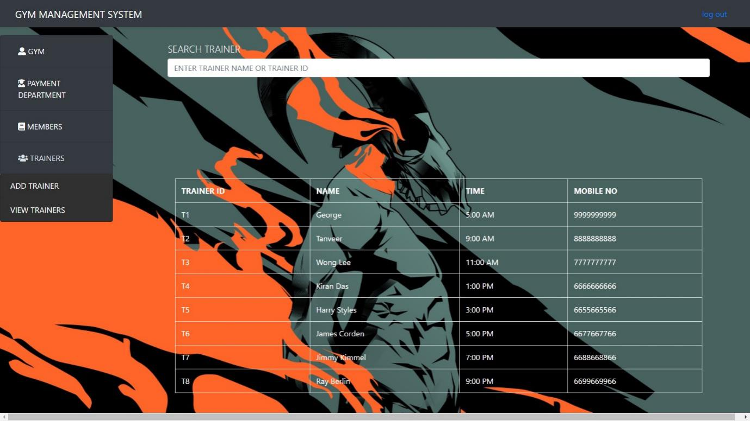

**CHAPTER - 5**

**SYSTEM REQUIREMENTS**

**Software Requirement:**

1. Front End: Chrome or Any Search Engine
2. Xampp x64 bit
3. Back End: Visual Studio Code or any Text Editor

**Hardware Requirement:**

1. Processor- Intel i3 or more
2. RAM- 2 GB or more
3. Hard Disk- 500GB or more

**CHAPTER - 6**

**PLAGIARISM CHECK**

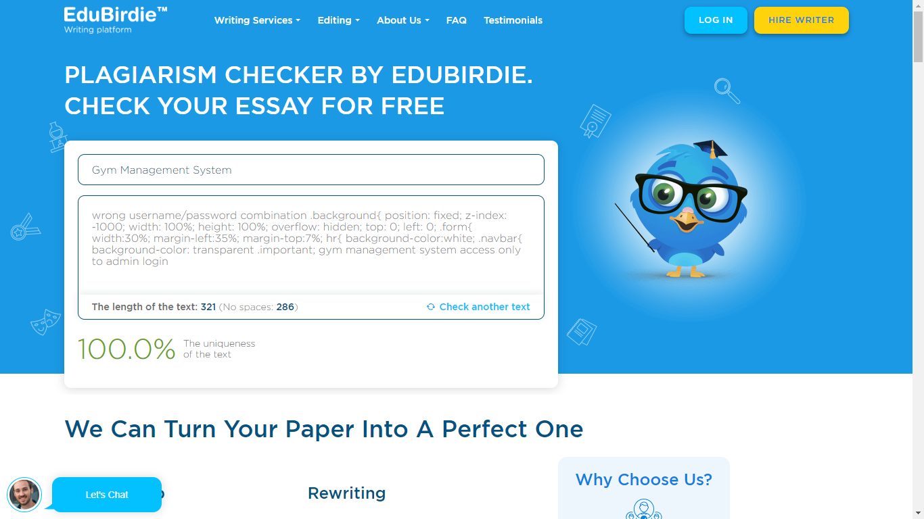

Plagiarism detection is the process of locating instances of plagiarism within a work or document. The widespread use of computers and the advent of the Internet have made it easier to plagiarize the work. With the free plagiarism checker by Edubirdie available online, the code for gym management system is verified and displays that the project code is unique.

**PLAGIARISM CHECKER OF CODE** – **100%** **UNIQUE**

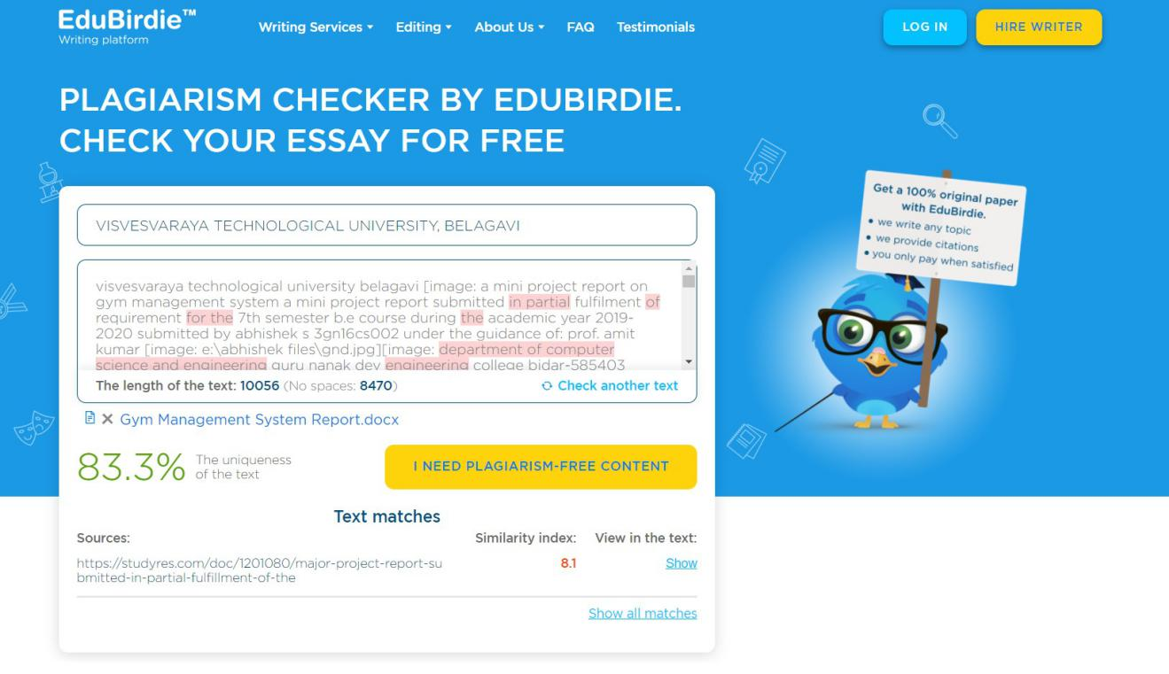

**PLAGIARISM CHECKER OF REPORT** – **83.3%** **UNIQUE**

**CHAPTER - 7**

**COST ESTIMATION OF PROJECT**

PROJECT NAME: **GYM MANAGEMENT SYSTEM**

|  |  |  |  |
| --- | --- | --- | --- |
| Sl. NO | PHASE | PROGRAMMING DAYS | ESTIMATED DAYS  (in INR) |
| 1 | Requirements | 5 | 1200 |
| 2 | Design | 7 | 1500 |
| 3 | Implementation | 10 | 1800 |
| 4 | Testing | 3 | 1500 |
| 5 | Installation | 5 | 1000 |
| 6 | Documentation | 8 | 1800 |

Total Cost: 8800 INR

**CHAPTER - 8**

**CONCLUSION**

While developing this project we have learnt a lot about HTML/CSS/JS/PHP/MySQL and working with database management, we have also learnt how to make the application user-friendly (easy to use and handle) by hiding the complicated parts of it from the users.

During the development process, we studied carefully and understood the criteria for making a software more demanding, we also realized the importance of maintaining a minimal margin for errors.